Kubernetes Fundamentals & Application Deployment
WEEK-4

Prepared by: M Tarun Kumar
Intern, PGSN SOFTTECH
July 2026

Table of Contents
- 1. Resource Requests & Limits
- 2. Kubernetes Pod: The Basic Building Block
- 3. Kubernetes Multi-Tier Application Architecture
- 4. Pod Replicas and Desired State
- 5. Kubernetes Architecture
- 6. Deployments and ReplicaSets
- 7. Kubernetes Service Types
- 8. ConfigMaps in Kubernetes
- 9. Kubernetes Secrets

1. Resource Requests & Limits

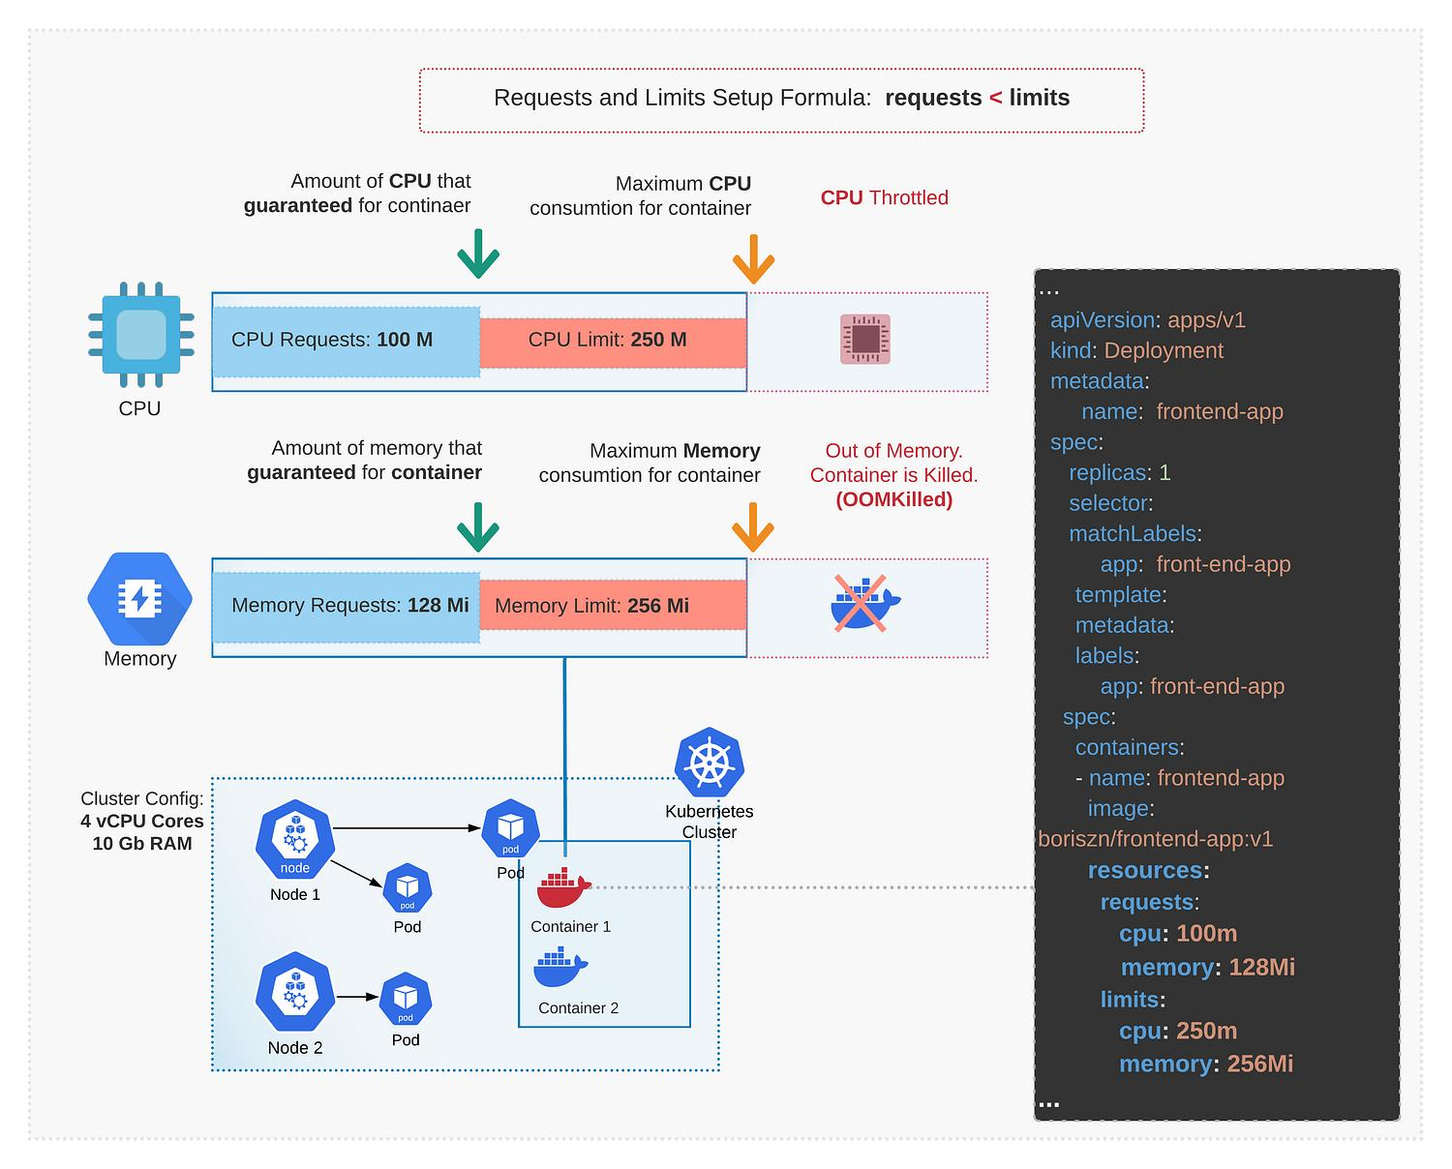

Overview
- This concept defines the computational resources (CPU and memory) guaranteed and restricted for containers.
- It exists to prevent a single container from monopolizing cluster resources and causing system crashes.
- Kubernetes uses this mechanism to determine optimal node scheduling for incoming Pods.
- It is implemented globally across Kubernetes clusters to ensure fair resource distribution.
- It operates at the container level within the Pod specification.
- Requests guarantee minimum availability, while limits cap maximum consumption.
- This ensures predictability in multi-tenant environments.

Diagram Explanation
- The diagram visualizes the mathematical relationship where Requests must be less than or equal to Limits.
- For CPU, a request of 100m guarantees a baseline, while a limit of 250m prevents spikes beyond that threshold.
- If a container attempts to exceed its CPU limit, the system forcibly throttles the CPU cycles without terminating the Pod.
- For Memory, a request of 128Mi guarantees RAM availability, while a 256Mi limit caps usage.
- Unlike CPU throttling, attempting to consume memory beyond the specified limit results in the container being aggressively terminated (OOMKilled).
- The bottom section maps these Pod-level constraints to the physical cluster configuration, showing how a 4 vCPU, 10GB RAM cluster distributes these isolated Pods across Worker Nodes.
- The YAML snippet on the right demonstrates how these logical concepts are written directly into a Deployment's manifest file.

Key Components
- CPU Request (100m):
- Guarantees exactly 0.1 CPU cores are reserved for the container.
- Used by the kube-scheduler to find a node with sufficient unallocated CPU.
- If a node lacks this baseline, the Pod remains in a Pending state.
- CPU Limit (250m):
- The hard maximum of CPU cycles the container can utilize.
- Enforced by the container runtime via cgroups.
- Exceeding this causes throttling, leading to slower processing but not termination.
- Memory Request (128Mi):
- Guarantees 128 Mebibytes of RAM are dedicated to the container.
- Crucial for application startup and baseline operations.
- Nodes subtract this value from their allocatable memory pool.
- Memory Limit (256Mi):
- The absolute maximum memory footprint allowed.
- Memory is non-compressible; if this limit is breached, the kernel intervenes.
- Triggers an Out Of Memory (OOM) Kill event to protect the host node.

Working Process
- Developer defines resource requests and limits within the Deployment YAML file.
- User applies the configuration to the cluster using kubectl.
- The API Server validates the configuration and persists it in etcd.
- The Scheduler evaluates all Worker Nodes to check for available unallocated capacity matching the Requests.
- The Scheduler assigns the Pod to a suitable Node (e.g., Node 1 or Node 2).
- The Kubelet on the selected Node instructs the Container Runtime to start the container.
- The Linux kernel (via cgroups) actively enforces the specified Limits during runtime.
- If memory limits are exceeded, the container is OOMKilled and automatically restarted based on the restart policy.

Advantages
- Prevents noisy neighbor problems by isolating resource consumption.
- Enables efficient and dense bin-packing of containers onto physical nodes.
- Protects cluster stability by preventing individual applications from crashing host servers.
- Provides clear boundaries for application performance testing.
- Simplifies capacity planning for cloud infrastructure scaling.

Common kubectl Commands
- kubectl top pod - Displays current real-time CPU and memory usage for running Pods.
- kubectl describe pod <pod-name> - Shows detailed resource allocation, including limits and requests, plus OOMKilled events.
- kubectl top node - Displays aggregated resource utilization across all cluster nodes.

Summary
- Requests represent the guaranteed baseline resources required for a container to function.
- Limits act as a safety ceiling to prevent unbounded resource consumption.
- CPU is a compressible resource; exceeding limits causes throttling and performance degradation.
- Memory is an incompressible resource; exceeding limits results in immediate container termination (OOMKilled).
- Proper configuration is critical for maintaining application uptime and minimizing cloud infrastructure costs.
- The kube-scheduler exclusively uses Requests, not Limits, to make node placement decisions.

2. Kubernetes Pod: The Basic Building Block

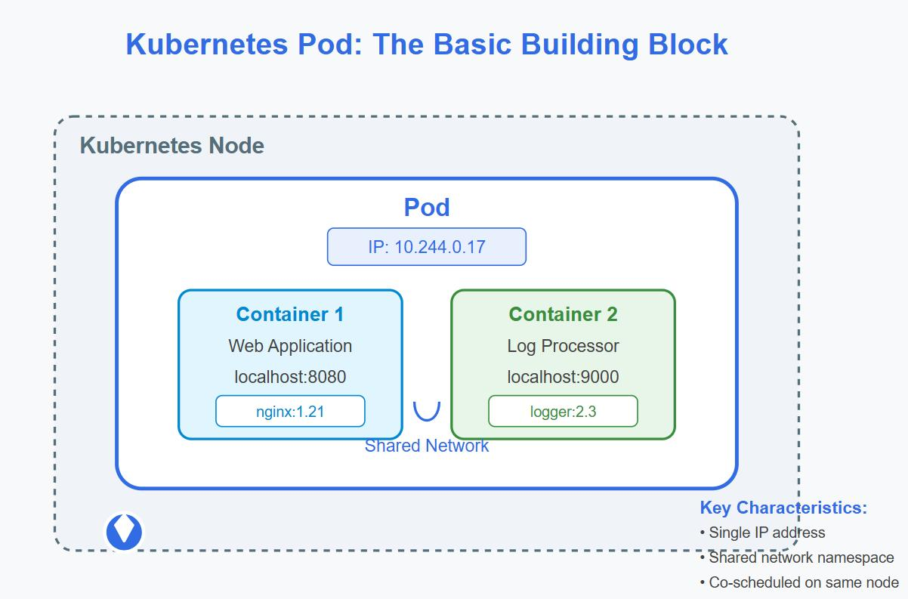

Overview
- A Pod is the smallest, most fundamental deployable object in the Kubernetes ecosystem.
- It exists to encapsulate one or more containers that need to share resources and execution context.
- Kubernetes uses Pods rather than individual containers to manage multi-process architectures efficiently.
- They are used universally across the cluster to host application workloads.
- A Pod acts as a logical host, simulating a standalone server environment for its containers.
- Pods are inherently ephemeral; they are designed to be replaced rather than repaired.

Diagram Explanation
- The diagram illustrates the structural hierarchy starting from the external Kubernetes Node down to the internal containers.
- The blue outer boundary represents the Pod itself, which is assigned a single unique IP address (10.244.0.17).
- Inside the Pod, a Shared Network namespace encompasses all running processes.
- Two distinct containers are running side-by-side: a Web Application (Container 1) and a Log Processor (Container 2).
- Because they share the same network space, they can communicate directly using standard localhost addressing.
- The Web Application operates on localhost:8080 while the Log Processor operates on localhost:9000.
- This tightly coupled architecture ensures that closely related helper processes (like the logger) are always co-located with the main application.

Key Components
- Kubernetes Node:
- The physical or virtual machine hosting the Pod.
- Provides the foundational compute resources.
- Managed by the Control Plane to ensure worker availability.
- Pod:
- The deployable wrapper around the containers.
- Provides a shared execution environment.
- Maintains the lifecycle for all enclosed containers simultaneously.
- Container 1 (Web Application):
- The primary application workload (e.g., an Nginx web server).
- Exposes the main business logic to users.
- Runs on a specific port mapped within the Pod's network.
- Container 2 (Log Processor):
- A supplementary 'sidecar' container.
- Enhances or supports the primary application without altering its code.
- Processes, formats, or forwards logs generated by Container 1.
- Shared Network:
- The unified networking context for the Pod.
- Allows containers to bypass external networking and use localhost.
- Ensures ultra-low latency communication between co-dependent containers.

Working Process
- A request to create a Pod is sent to the Kubernetes API Server.
- The Scheduler analyzes cluster capacity and selects an appropriate Node.
- The Kubelet on the selected Node receives the Pod specification.
- The Container Runtime pulls the required container images (e.g., nginx:1.21 and logger:2.3).
- The shared network namespace is established, and the IP address is assigned.
- Both Container 1 and Container 2 are started within this shared namespace.
- Container 1 begins serving web traffic on port 8080.
- Container 2 simultaneously reads application logs and processes them on port 9000.

Advantages
- Simplifies inter-process communication using standard localhost networking.
- Allows seamless sharing of storage volumes between containers in the same Pod.
- Facilitates the sidecar pattern for logging, monitoring, and security proxies.
- Ensures co-dependent containers are always scheduled on the exact same physical node.
- Abstracts away container engine specificities from the deployment logic.

Common kubectl Commands
- kubectl get pods - Lists all Pods in the current namespace along with their status.
- kubectl describe pod <pod-name> - Provides exhaustive configuration details, network IPs, and recent events for a Pod.
- kubectl logs <pod-name> -c <container-name> - Retrieves logs from a specific container within a multi-container Pod.
- kubectl exec -it <pod-name> -- /bin/sh - Opens an interactive shell inside a running Pod for debugging.

Summary
- Pods are the atomic units of scheduling in Kubernetes, not raw containers.
- Every Pod receives a single, cluster-routable IP address.
- Multiple containers inside a Pod share the same network namespace and IP.
- Containers within a Pod communicate seamlessly over localhost.
- Pods allow the implementation of advanced architectural patterns like sidecars and ambassadors.
- They are transient entities designed to be destroyed and recreated dynamically.

3. Kubernetes Multi-Tier Application Architecture
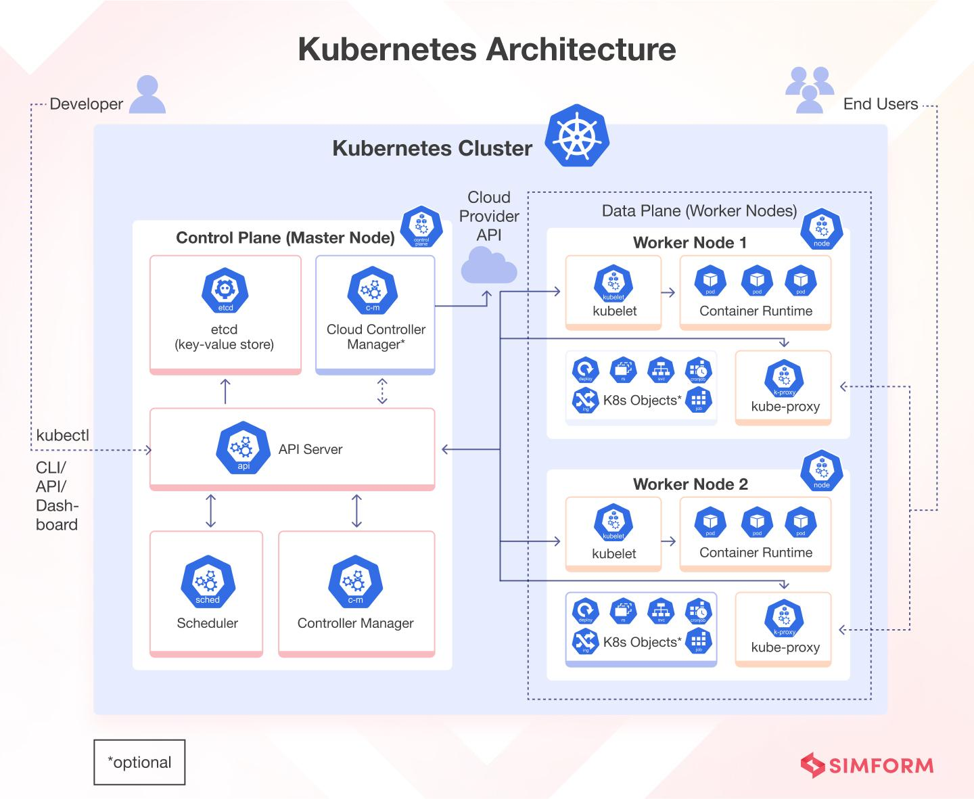

Overview
- This concept represents a comprehensive, production-ready enterprise application deployed within a cluster.
- It exists to demonstrate how various Kubernetes objects interact to form a highly available software system.
- Kubernetes uses this tiered approach to isolate concerns, scale components independently, and secure internal traffic.
- It is used for deploying complex applications like e-commerce platforms or enterprise SaaS products.
- The architecture distinctly separates external access, stateless logic tiers, and stateful data storage.
- It incorporates configuration management, security, and observability into a single holistic environment.

Diagram Explanation
- The diagram maps the complete traffic flow from external users on the internet down to persistent database storage.
- External traffic reaches the NGINX Ingress Controller, which acts as an intelligent HTTP/HTTPS router.
- The Ingress resource routes traffic based on URL paths: '/' goes to the Frontend Service, and '/api' goes to the Backend Service.
- Services act as internal load balancers, distributing traffic to the underlying Deployment Pods via ClusterIPs.
- The Frontend Deployment manages UI Pods, while the Backend Deployment manages API logic Pods.
- The Backend securely communicates with a stateful MySQL Deployment, which is backed by a PersistentVolumeClaim.
- ConfigMaps and Secrets inject necessary environment variables and passwords into the Pods without hardcoding them.
- Network Policies explicitly define security rules, ensuring only the frontend can talk to the backend, and only the backend can talk to the database.

Key Components
- Ingress / Ingress Controller:
- The external gateway managing incoming internet traffic.
- Provides SSL termination and host/path-based routing.
- Replaces the need for multiple expensive cloud LoadBalancers.
- Frontend & Backend Services:
- Stable internal IP addresses for ephemeral Pods.
- Provide continuous load balancing across all available replicas.
- Ensure seamless communication even as backend Pods are destroyed and recreated.
- Deployments:
- Manage the declarative state of the stateless frontend and backend applications.
- Handle automated rolling updates and zero-downtime rollbacks.
- Maintain the desired number of replicas actively running across Worker Nodes.
- MySQL Deployment & PV/PVC:
- Handles the stateful database workload.
- Utilizes Persistent Volume Claims to ensure data survives Pod restarts.
- Connects to physical Node Disk storage for durable data retention.
- ConfigMaps & Secrets:
- Decouple configuration artifacts from container images.
- ConfigMaps store non-sensitive data like NGINX configurations.
- Secrets securely store encrypted assets like database passwords and API keys.
- Network Policies:
- Acts as an internal firewall within the cluster.
- Dictates permitted traffic flows between Pods.
- Prevents unauthorized access (e.g., blocking the frontend from directly querying MySQL).

Working Process
- A User accesses app.example.com via their web browser.
- DNS resolves the request to the NGINX Ingress Controller.
- The Ingress Controller reads routing rules and forwards the request to the Frontend Service.
- The Frontend Service load-balances the request to one of the available Frontend Pods.
- The Frontend Pod makes an API call to api.example.com/api, which routes to the Backend Service.
- The Backend Pod processes the logic and queries the MySQL Database Pod.
- The MySQL Pod retrieves data from the attached Persistent Volume.
- The response traverses back up the chain to the external User.

Advantages
- Microservices can be scaled entirely independently based on specific tier bottlenecks.
- Strict network isolation enhances security and minimizes the blast radius of a breach.
- Data persistence guarantees that critical database records are not lost during cluster updates.
- Centralized ingress routing drastically reduces public IP and load balancer costs.
- Configuration decoupling allows identical container images to run in Staging and Production environments.

Common kubectl Commands
- kubectl get all - Displays a high-level overview of Deployments, Pods, and Services in the namespace.
- kubectl get ingress - Lists the configured ingress rules and their assigned external IP addresses.
- kubectl describe networkpolicy - Shows the specific ingress and egress rules applied for internal firewalling.
- kubectl get pvc - Verifies the status of storage claims attached to the stateful components.

Summary
- Multi-tier architectures separate frontend, backend, and data storage into distinct logical layers.
- Ingress provides intelligent, cost-effective routing for external HTTP/HTTPS traffic.
- Services ensure reliable internal communication between volatile Pod environments.
- Stateful components utilize Persistent Volumes to safeguard data against Pod termination.
- ConfigMaps and Secrets ensure applications remain environment-agnostic and secure.
- Network Policies implement zero-trust security principles within the cluster perimeter.

4. Pod Replicas and Desired State
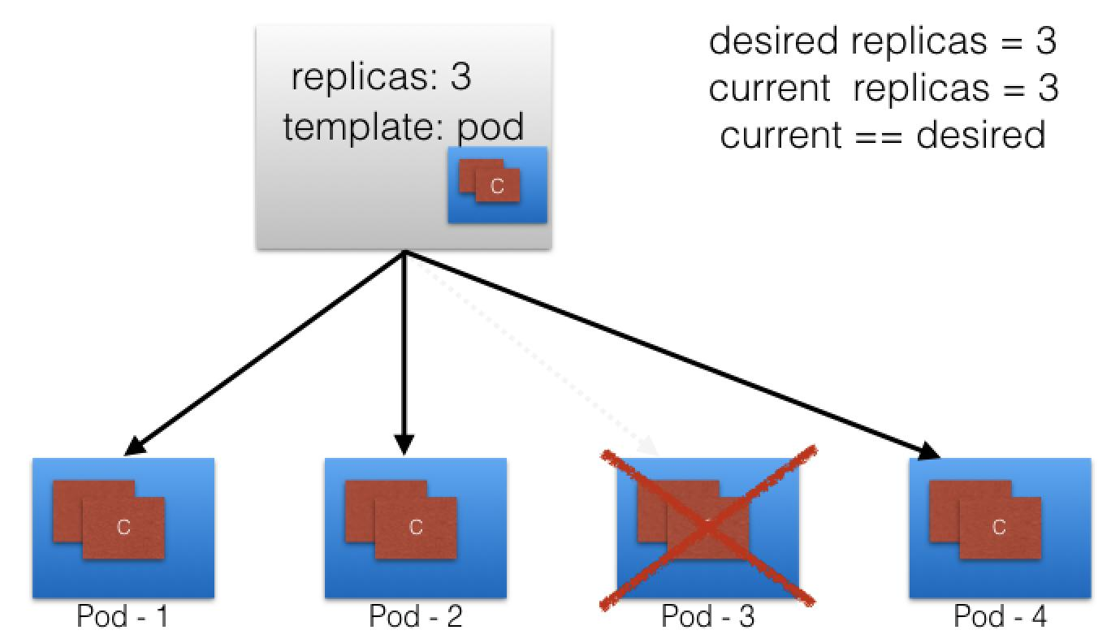

Overview
- This concept illustrates the self-healing and scaling mechanism of Kubernetes ReplicaSets.
- It exists to ensure high availability and application reliability even in the face of hardware or software failures.
- Kubernetes uses a continuous control loop to constantly compare the current state with the desired state.
- It is used to maintain a consistent baseline of application instances to handle user traffic.
- Replica management abstracts the burden of manual application recovery away from system administrators.
- It forms the foundation of automated scaling operations.

Diagram Explanation
- The diagram visualizes a configuration block specifying 'replicas: 3' alongside a generic Pod template.
- This configuration defines the 'Desired State'—the system mandate that exactly three identical Pods must exist.
- Initially, the 'Current State' successfully matches the desired state, with Pod-1, Pod-2, and Pod-3 running normally.
- The diagram then depicts a failure scenario where Pod-3 crashes or is abruptly terminated (indicated by the red X).
- As soon as Pod-3 dies, the current state drops to 2, which violates the desired state formula (current != desired).
- To rectify this, the Kubernetes controller automatically spins up a brand new instance, Pod-4, derived from the original template.
- Once Pod-4 is fully initialized, the current state returns to 3, restoring cluster equilibrium (current == desired).

Key Components
- Desired State Configuration:
- The declarative YAML specification (usually within a Deployment).
- Defines the exact number of replicas required.
- Acts as the single source of truth for application availability.
- Pod Template:
- The blueprint used to stamp out identical application instances.
- Contains the container image, ports, and configuration logic.
- Ensures all replicas are perfectly homogenous.
- Active Pods (Pod-1, Pod-2):
- The currently healthy and running instances.
- Actively receiving and processing application traffic.
- Monitored continuously by the Control Plane.
- Failed Pod (Pod-3):
- A Pod that has crashed due to application errors or node failure.
- Detected by missed health checks or process termination.
- Immediately removed from the Service endpoints to stop traffic routing.
- Replacement Pod (Pod-4):
- The newly provisioned instance created to restore balance.
- Scheduled on any available healthy node in the cluster.
- Seamlessly integrated into the application pool once ready.

Working Process
- The Administrator submits a Deployment manifest defining exactly 3 desired replicas.
- The Controller Manager reads this and provisions 3 Pods (Current = 3).
- A node failure occurs, causing Pod-3 to instantly crash and become unavailable.
- The Controller Manager detects that Current Replicas (2) is less than Desired Replicas (3).
- The Controller automatically requests the creation of a new Pod from the original template.
- The Scheduler assigns the new Pod-4 to a healthy node.
- Pod-4 starts up, and the controller confirms that Current State once again equals Desired State.

Advantages
- Provides fully automated self-healing without requiring human intervention.
- Guarantees a consistent level of application availability to meet SLAs.
- Allows for effortless horizontal scaling (scaling out) during high traffic spikes.
- Prevents partial outages from escalating into total application downtime.
- Eliminates the need for traditional manual server monitoring and restarting.

Common kubectl Commands
- kubectl get replicaset - Displays the current number of desired, current, and ready replicas.
- kubectl scale deployment <name> --replicas=5 - Manually adjusts the desired state to scale the application horizontally.
- kubectl delete pod <pod-name> - Manually kills a Pod, instantly demonstrating the ReplicaSet's automatic self-healing capability.

Summary
- ReplicaSets continuously monitor and maintain a designated number of active Pods.
- The system operates entirely on a declarative Desired State model.
- Any deviation between desired state and current state triggers immediate automated correction.
- Failed Pods are never restarted; they are entirely replaced with identical fresh instances.
- This continuous reconciliation loop is the core driver of Kubernetes reliability.
- Replica management guarantees application resilience against random infrastructure failures.

5. Kubernetes Architecture
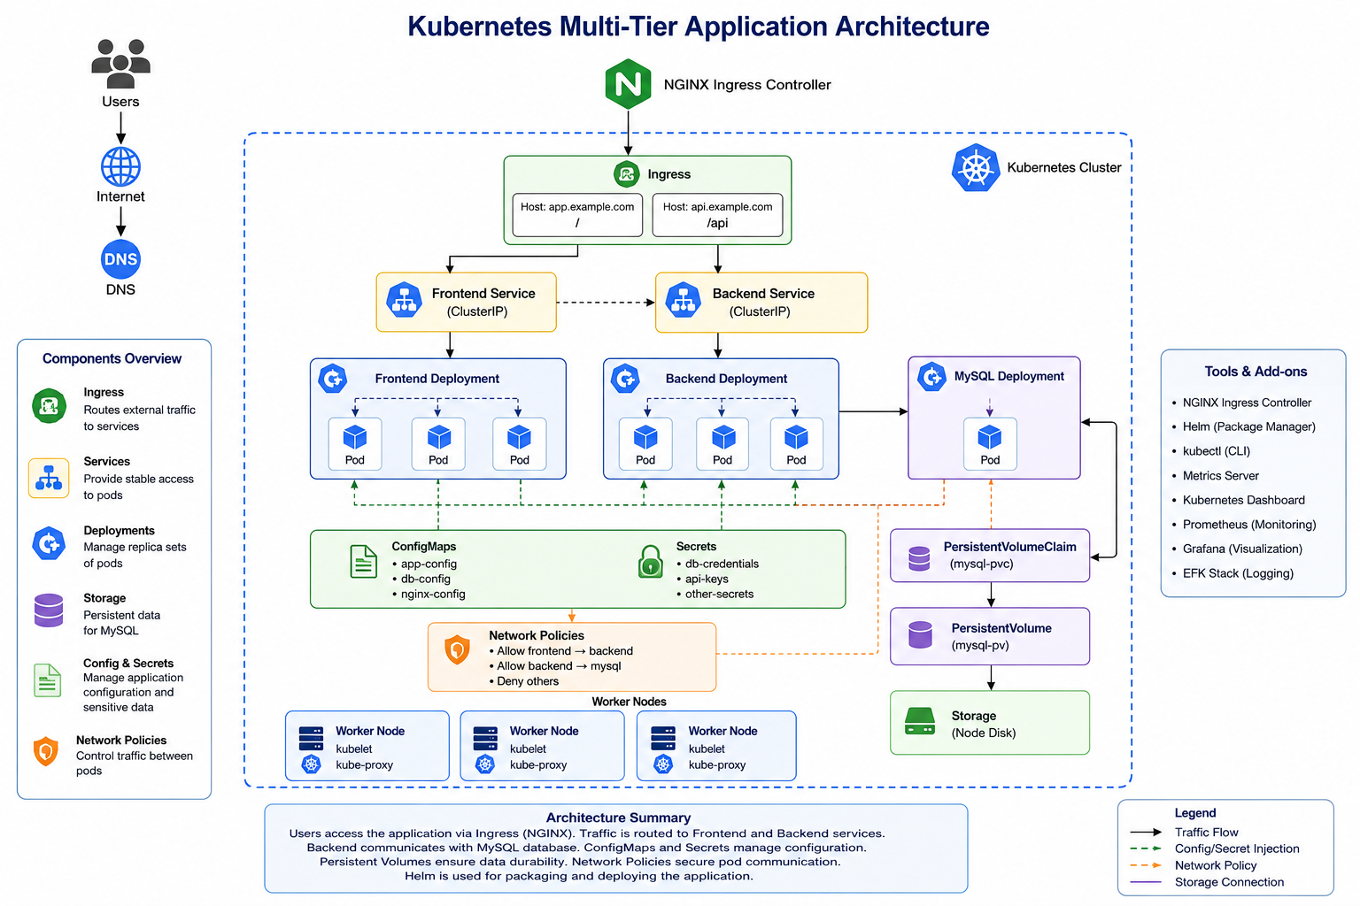

Overview
- This concept maps the complete internal structural hierarchy of a Kubernetes cluster.
- It exists to separate cluster management operations from actual application workloads.
- Kubernetes uses this master-worker model to distribute computing tasks efficiently and securely.
- It is universally used as the foundational blueprint for all Kubernetes deployments, whether on-premise or cloud.
- The architecture relies heavily on API-driven communication between isolated components.
- It ensures the system remains scalable, highly available, and resilient.

Diagram Explanation
- The diagram divides the cluster into two primary domains: The Control Plane (Master Node) and the Data Plane (Worker Nodes).
- On the left, the Control Plane acts as the brain. External Developers and Administrators interact exclusively with the API Server via kubectl or dashboards.
- The API Server acts as the central communication hub, writing all state changes to the etcd key-value store.
- The Scheduler watches for incoming Pod requests and assigns them to available Worker Nodes, while the Controller Manager continuously monitors cluster state.
- The optional Cloud Controller Manager interfaces with external Cloud Provider APIs (like AWS or GCP).
- On the right, the Data Plane consists of Worker Nodes that actually run the applications.
- Each node runs a kubelet (the node's agent that talks to the API Server) and kube-proxy (managing network rules).
- The Container Runtime on each node executes the actual Pods containing application code, which ultimately serve the End Users.

Key Components
- API Server:
- The central gateway and sole entry point to the cluster.
- Validates and processes all REST requests from users and internal components.
- The only component permitted to interact directly with the etcd database.
- etcd:
- A highly available, distributed key-value store.
- Acts as the definitive source of truth for all cluster data.
- Stores the configuration, state, and metadata of the entire system.
- Scheduler:
- The intelligent decision-maker for workload placement.
- Evaluates node resources, hardware constraints, and affinity rules.
- Assigns unassigned Pods to the most optimal physical worker node.
- Controller Manager:
- The background reconciliation engine.
- Runs various controllers (Node, ReplicaSet, Endpoint) in a continuous loop.
- Detects state drift and actively pushes the cluster back to the desired state.
- kubelet:
- The primary node agent running on every single Worker Node.
- Receives instructions from the API Server to start or stop Pods.
- Continuously monitors local containers and reports their health back to the master.
- kube-proxy & Container Runtime:
- kube-proxy maintains local network IP tables for service routing.
- Container Runtime (e.g., containerd) handles pulling images and running isolated processes.
- Together, they enable networking and execution for the application Pods.

Working Process
- A Developer uses the kubectl CLI to submit a deployment request.
- The API Server authenticates the user, validates the request, and saves the new configuration into etcd.
- The Controller Manager detects the new deployment and creates the necessary ReplicaSet.
- The Scheduler detects newly created Pods that have no assigned Node.
- The Scheduler analyzes node metrics, selects Worker Node 1, and updates the API Server.
- The kubelet on Worker Node 1 sees the assignment and instructs the Container Runtime to pull the image and launch the Pod.
- kube-proxy updates local networking rules so traffic can reach the new Pod.
- End Users connect to the cluster and are routed to the running application.

Advantages
- Strict separation of control and data planes prevents workload failures from crashing management systems.
- A centralized API Server ensures all cluster communication is highly secure and auditable.
- Distributed architecture allows the system to scale massively across thousands of physical servers.
- Automated scheduling optimizes hardware utilization and reduces cloud costs.
- Modular components allow easy integration with diverse cloud providers and networking plugins.

Common kubectl Commands
- kubectl cluster-info - Displays the primary addresses of the API server and essential cluster services.
- kubectl get nodes - Lists all active Control Plane and Worker Nodes along with their readiness status.
- kubectl get componentstatuses - Provides a health check for the core Control Plane components (etcd, scheduler, controller-manager).

Summary
- The Control Plane makes global decisions and manages the overarching cluster state.
- The Data Plane executes the application workloads and handles physical networking.
- The API Server acts as the central communication nervous system.
- etcd acts as the secure memory bank storing all configuration data.
- Kubelets act as loyal agents on worker nodes, executing API Server commands.
- This declarative, distributed design makes Kubernetes incredibly powerful and resilient.
6. Deployments and ReplicaSets
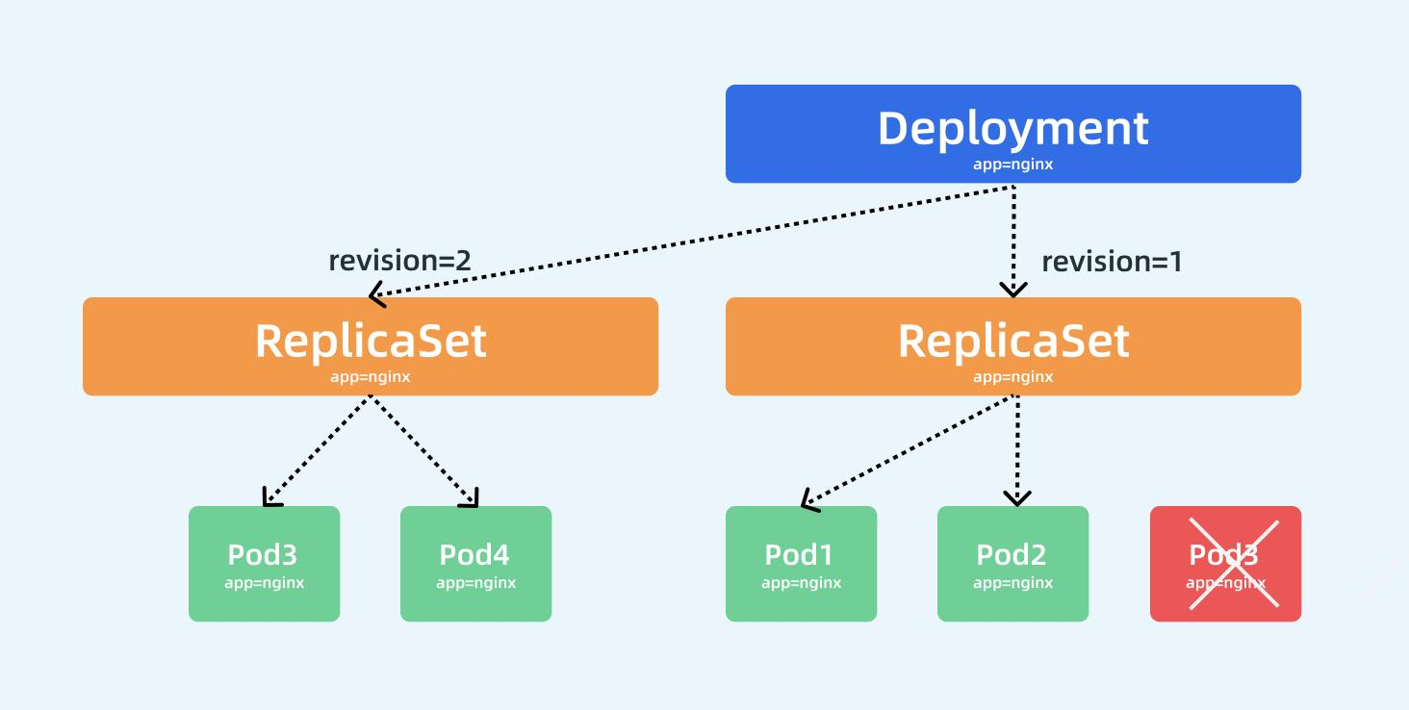

Overview
- This concept visualizes how Kubernetes manages seamless application updates and version control.
- It exists to allow organizations to release new software versions without experiencing user downtime.
- Kubernetes uses Deployments as a higher-level abstraction to orchestrate underlying ReplicaSets automatically.
- It is used universally for managing the lifecycle of stateless applications.
- Deployments completely remove the risk and manual effort of traditional software patching.
- They provide built-in rollback mechanisms if a new release fails.

Diagram Explanation
- The diagram illustrates the hierarchical relationship: A Deployment oversees ReplicaSets, and ReplicaSets oversee Pods.
- The top blue box represents the core Deployment object responsible for managing an application labeled 'app=nginx'.
- Below it, the system maintains a history of software releases, shown as Revision 1 and Revision 2.
- During an update, the Deployment creates a new ReplicaSet (revision=2) while keeping the old one (revision=1) temporarily intact.
- The diagram captures a rolling update mid-process: The old ReplicaSet is slowly scaling down (Pod3 is being destroyed, indicated by the red X).
- Simultaneously, the new ReplicaSet is scaling up (bringing Pod3 and Pod4 online with the new code).
- This transition continues iteratively until the old ReplicaSet has zero pods and the new ReplicaSet has the full desired count.

Key Components
- Deployment:
- The declarative management object facing the user.
- Defines the desired software version and the deployment strategy (e.g., RollingUpdate).
- Acts as the overall supervisor managing release history and rollbacks.
- ReplicaSet (revision=1):
- Represents the older, currently running version of the application.
- During an update, its desired pod count is systematically reduced to zero.
- Kept in the cluster history specifically to facilitate immediate rollbacks if needed.
- ReplicaSet (revision=2):
- Represents the new, updated version of the application.
- Gradually scales up its pod count to match the overall desired state.
- Takes over all application traffic seamlessly as it initializes.
- Pods (app=nginx):
- The actual containers running the specific software versions.
- Traffic is dynamically load-balanced across healthy Pods from both revisions during the transition.
- Ensures end-users experience zero disruption during the patch.

Working Process
- The administrator updates the container image version in the Deployment manifest (e.g., from v1 to v2).
- The Deployment controller detects this change and creates a brand new ReplicaSet (revision=2).
- The controller instructs revision=2 to scale up by one Pod.
- Once the new Pod is healthy and ready, the controller instructs revision=1 to scale down by one Pod.
- This iterative process (spin one up, kill one down) repeats systematically.
- Eventually, revision=2 reaches the full desired replica count.
- Revision=1 reaches zero Pods, completing the zero-downtime rolling update.

Advantages
- Enables true zero-downtime deployments, crucial for modern web services.
- Provides instant, single-command rollbacks if a newly deployed version contains critical bugs.
- Maintains a clear, automated history of all application revisions.
- Allows customized upgrade strategies (controlling how many pods surge or become unavailable during updates).
- Abstracts away the complex manual scaling operations of individual ReplicaSets.

Common kubectl Commands
- kubectl set image deployment/<name> <container>=<new-image:v2> - Triggers a rolling update by changing the application image.
- kubectl rollout status deployment/<name> - Allows administrators to watch the progress of the rolling update in real-time.
- kubectl rollout history deployment/<name> - Displays the version history and revisions of the deployment.
- kubectl rollout undo deployment/<name> - Instantly reverts the application back to the previous stable revision.

Summary
- Deployments manage ReplicaSets; ReplicaSets manage Pods.
- A new application version automatically generates a new ReplicaSet.
- Rolling updates slowly transition traffic from the old ReplicaSet to the new one.
- Old ReplicaSets are scaled to zero but retained for rapid rollback capability.
- This mechanism guarantees continuous availability during CI/CD pipelines.
- Deployments are the standard, best-practice method for running stateless workloads.

7. Kubernetes Service Types

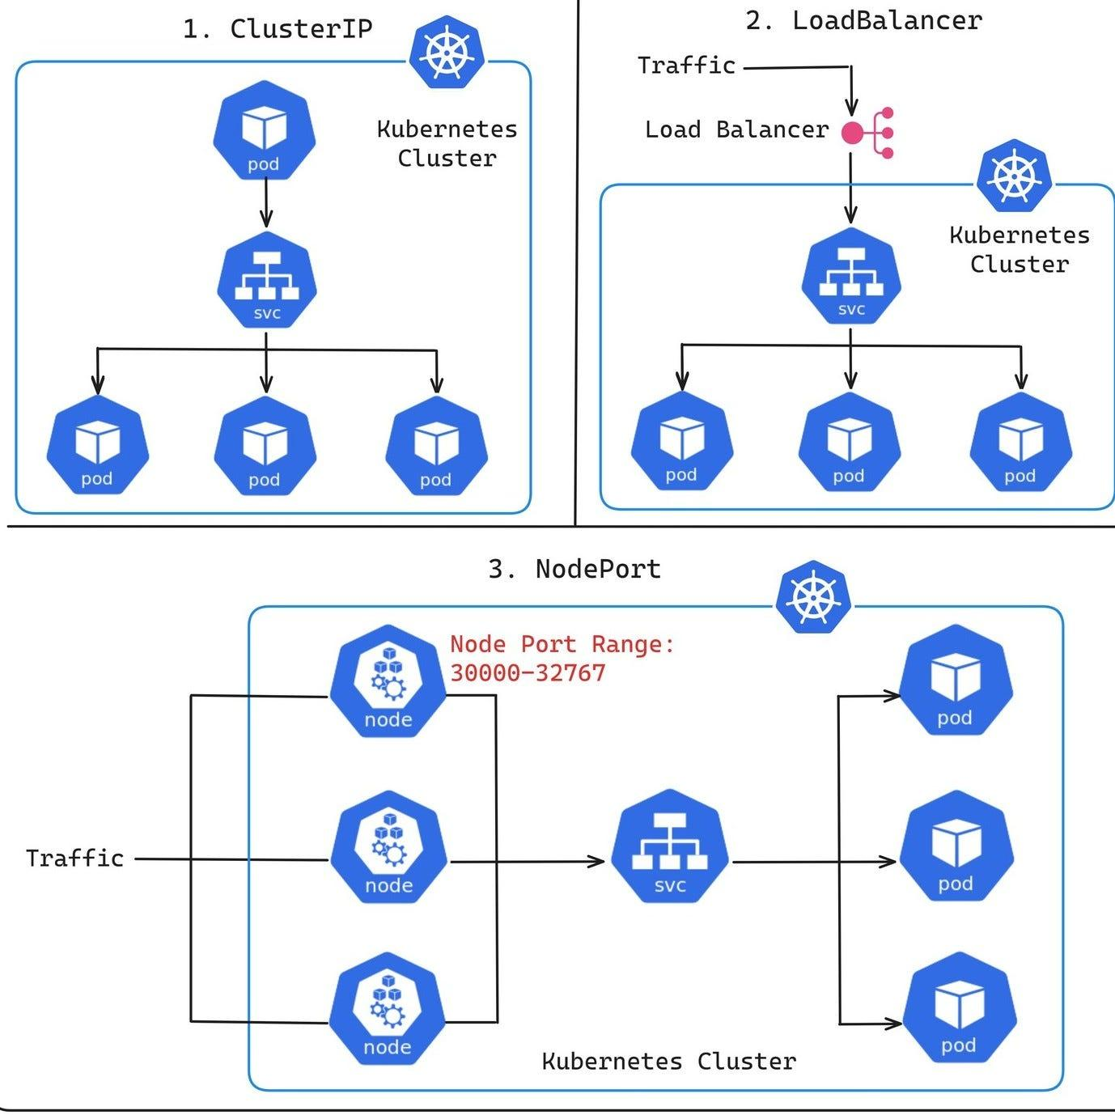

Overview
- This concept defines the various networking methods for exposing applications within and outside the cluster.
- It exists because Pod IPs are ephemeral and change constantly; Services provide stable networking.
- Kubernetes uses Services to decouple frontend client requests from backend worker availability.
- They are used to dictate exactly how, where, and to whom an application is accessible.
- Services manage internal load balancing automatically via network iptables.
- Choosing the correct Service type is fundamental to cluster security and accessibility.

Diagram Explanation
- The diagram clearly breaks down the three primary Service configurations available in Kubernetes.
- 1. ClusterIP (Top Left): The default networking type. It creates a completely isolated, internal virtual IP. Traffic remains trapped inside the Kubernetes Cluster boundary, allowing internal Pods to communicate securely without external exposure.
- 2. LoadBalancer (Top Right): Builds upon the ClusterIP by integrating with a cloud provider. It requests a physical Load Balancer (like AWS ELB), which funnels external internet traffic directly through to the internal Service.
- 3. NodePort (Bottom): Opens a specific static port (between 30000-32767) on every single physical Worker Node in the cluster. External traffic hitting any node's IP on that specific port is automatically routed inward to the Service, and subsequently to the correct Pods.

Key Components
- ClusterIP:
- The default and most secure Service type.
- Generates an IP address only routable from inside the cluster.
- Perfect for backend databases or internal microservices that should never see the public internet.
- LoadBalancer:
- The standard method for exposing public-facing web applications.
- Automatically provisions external cloud networking hardware.
- Provides a single, stable public IP address or DNS name for users to access.
- NodePort:
- A primitive way to allow external access without cloud provider integration.
- Opens a high-range port directly on the host machine's firewall.
- Often used in bare-metal deployments or localized testing environments.
- Service Object (svc):
- The logical load balancer sitting in front of the Pods.
- Uses label selectors (e.g., app=frontend) to dynamically track which Pods belong to it.
- Updates its internal routing table instantly when Pods die or scale.

Working Process
- A Deployment provisions multiple ephemeral Pods with constantly changing IPs.
- A Service is created with a selector matching those Pods' labels.
- The Service establishes a stable IP/Port combination.
- For ClusterIP: Internal microservices send traffic to this stable internal IP.
- For NodePort: External clients send traffic to any Node's IP at port 30080.
- For LoadBalancer: Cloud load balancer receives public traffic and forwards it to the NodePort, which goes to the Service.
- The Service evaluates its active endpoint list and routes the packet to one healthy Pod.

Advantages
- Decouples service consumption from the highly volatile Pod lifecycle.
- Provides built-in, highly efficient Layer 4 load balancing without third-party software.
- Ensures backend services remain invisible and secure from the public web.
- Integrates natively with major cloud providers for effortless public exposure.
- Simplifies internal DNS resolution (services can be accessed by their internal name).

Common kubectl Commands
- kubectl get svc - Lists all Services, showing their types, Cluster-IPs, and exposed External-IPs.
- kubectl describe svc <service-name> - Displays the specific Pod endpoints currently receiving traffic from the Service.
- kubectl expose deployment <name> --type=LoadBalancer --port=80 - Quickly creates a Service to expose an existing Deployment to the internet.

Summary
- Services provide stable, reliable networking for ephemeral Pods.
- ClusterIP is for private, internal-only cluster communication.
- NodePort opens a specific port on physical nodes for basic external access.
- LoadBalancer integrates with cloud providers to provision production-grade external access.
- Services use label selectors to dynamically route traffic only to healthy Pods.
- They are an absolute requirement for microservice communication and user accessibility.

8. ConfigMaps in Kubernetes
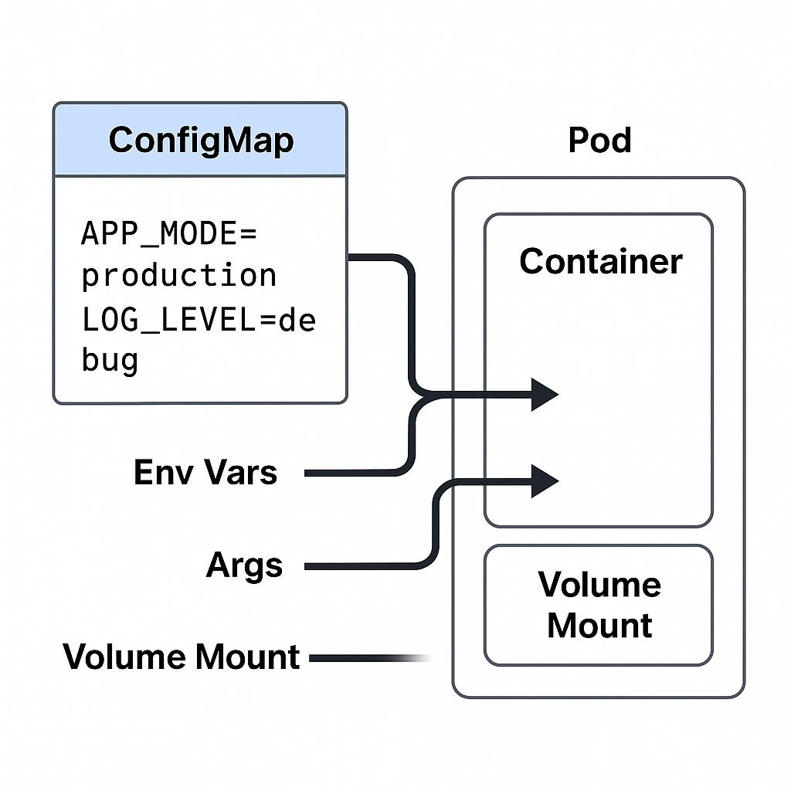

Overview
- This concept addresses the decoupling of non-sensitive configuration data from application code.
- It exists to adhere to modern application development principles, ensuring code is environment-agnostic.
- Kubernetes uses ConfigMaps to inject variables dynamically when a container starts.
- They are used to manage things like application modes, file paths, and general environment settings.
- ConfigMaps prevent the need to rebuild entire container images just to change a simple configuration value.
- They drastically increase the reusability of container artifacts across different environments.

Diagram Explanation
- The diagram illustrates the flow of configuration data from a centralized Kubernetes object into a running application.
- On the left, the ConfigMap object acts as a dictionary, storing key-value pairs such as APP_MODE=production and LOG_LEVEL=debug.
- The diagram highlights three distinct pathways by which this data is injected into the target Pod.
- First, data can be injected as standard Environment Variables (Env Vars) directly into the Container's process space.
- Second, the data can be passed as Command Line Arguments (Args) executed when the container starts.
- Third, the data can be injected via a Volume Mount, where the ConfigMap keys become physical files inside a directory within the container's file system.
- This flexibility ensures that legacy applications expecting file-based configs and modern applications expecting environment variables are both fully supported.

Key Components
- ConfigMap Object:
- The Kubernetes resource storing non-confidential configuration data.
- Stored securely within the etcd database.
- Can be created from literal values, environment files, or entire configuration files.
- Environment Variables (Env Vars):
- The most common method for modern 12-factor apps.
- The ConfigMap keys are mapped to OS-level environment variables inside the container.
- Easily read by programming languages (e.g., process.env in Node.js).
- Command-line Arguments (Args):
- Overrides the default startup command defined in the Dockerfile.
- Injects ConfigMap values directly into the execution string.
- Useful for dynamically passing flags to binary executables.
- Volume Mount:
- A method to present configuration as physical files.
- The ConfigMap is mounted as a read-only directory inside the Pod.
- Changes to the ConfigMap update the mounted files in real-time, allowing hot-reloading.

Working Process
- The DevOps engineer creates a ConfigMap containing staging or production variables.
- The developer writes a Pod Deployment YAML referencing this ConfigMap.
- The API Server validates the configuration request.
- As the Kubelet starts the Pod, it intercepts the ConfigMap request.
- The Kubelet injects the specified key-value pairs as environment variables into the container namespace.
- Alternatively, it creates a virtual volume, populates it with the ConfigMap data, and mounts it into the container's filesystem.
- The application starts and reads its configuration seamlessly.

Advantages
- The exact same Docker image can be used in Development, Staging, and Production environments.
- Significantly reduces the size and complexity of Dockerfiles.
- Provides centralized management of application settings.
- Allows applications supporting hot-reload to update configurations without restarting the Pod.
- Separates operations concerns (configuration) from development concerns (code).

Common kubectl Commands
- kubectl create configmap <name> --from-literal=key=value - Quickly creates a ConfigMap directly from the command line.
- kubectl get cm - Lists all ConfigMaps available in the current namespace.
- kubectl describe cm <name> - Displays the actual key-value pairs stored within the ConfigMap object.

Summary
- ConfigMaps isolate configuration data from containerized application code.
- They only store non-sensitive data (unlike Secrets).
- Data can be injected via Environment Variables, Arguments, or Volume Mounts.
- Volume Mounts support live-updating of configuration files without container restarts.
- They enforce the best practice of environment-agnostic deployment artifacts.
- ConfigMaps streamline the CI/CD pipeline by removing hardcoded variables.

9. Kubernetes Secrets
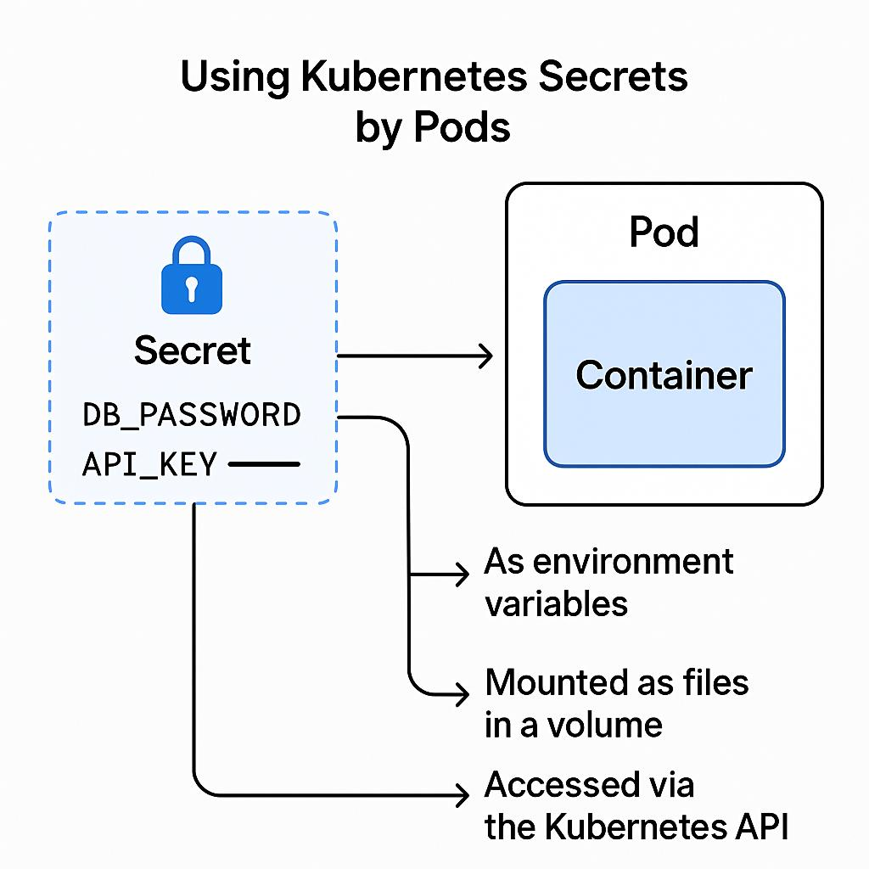

Overview
- This concept focuses on the secure storage and management of highly sensitive information.
- It exists to prevent critical security data from being exposed in plain text within application code or version control.
- Kubernetes uses Secrets to obfuscate and protect credentials needed by application workloads.
- They are used for database passwords, API keys, SSH keys, and TLS certificates.
- Secrets function mechanically similar to ConfigMaps but include additional layers of base64 encoding and security controls.
- Proper Secret management is a cornerstone of cluster security and compliance.

Diagram Explanation
- The diagram mirrors the ConfigMap workflow but emphasizes the secure nature of the source object (indicated by the lock icon).
- On the left, the Secret object holds critical credentials such as DB_PASSWORD and API_KEY.
- Because of their sensitive nature, these values are stored and transmitted securely.
- The diagram outlines the various secure pathways to deliver this data into the Container.
- The first path is via Environment Variables, where the application reads the secret directly from the OS environment.
- The second path is via Volume Mounting, where the secret is written as a hidden file into a temporary, memory-backed filesystem (tmpfs) rather than physical disk storage.
- The third path demonstrates that specialized applications or operators can programmatically query the Kubernetes API to retrieve the Secret directly, assuming they have the correct RBAC permissions.

Key Components
- Secret Object:
- The secure storage resource within Kubernetes.
- By default, values are Base64 encoded (though administrators should configure at-rest encryption).
- Strictly access-controlled via Role-Based Access Control (RBAC).
- Environment Variable Injection:
- Passes the decrypted secret directly into the application process.
- Highly convenient for applications expecting standard variable injection.
- Can pose a slight security risk if crash logs dump environment variables.
- Volume Mount (tmpfs):
- The most secure method of injecting credentials.
- Secrets are mounted as files in a virtual memory disk.
- They are never written to the physical hard drive, ensuring they vanish when the Pod terminates.
- Kubernetes API Access:
- Allows complex orchestrators (like Helm or Operators) to read secrets.
- Requires specialized ServiceAccounts and strict RBAC binding.
- Enables dynamic secret generation and rotation.

Working Process
- The security team provisions a Secret containing a production database password.
- The application Deployment manifest is configured to reference this specific Secret key.
- When the Pod is scheduled, the Kubelet securely requests the Secret from the API Server.
- The API Server verifies that the Pod's ServiceAccount has permission to read the Secret.
- The Kubelet receives the Secret and decodes it.
- The Kubelet mounts the secret into a RAM-disk (tmpfs) attached to the container.
- The application reads the password file securely from the RAM-disk.

Advantages
- Completely eliminates hardcoded passwords from Git repositories.
- Mitigates the risk of credential leakage during container inspection.
- Allows security teams to rotate passwords independently of the application lifecycle.
- Volume mounted secrets automatically update in the container if the underlying Secret object changes.
- Leverages Kubernetes RBAC for granular access control to sensitive data.

Common kubectl Commands
- kubectl create secret generic <name> --from-literal=password=123 - Creates a generic secret with a specific key-value pair.
- kubectl get secrets - Lists available secrets in the namespace (without revealing contents).
- kubectl get secret <name> -o yaml - Displays the secret manifest, showing the Base64 encoded values.

Summary
- Secrets are designed specifically for passwords, tokens, and certificates.
- They share a similar injection mechanism to ConfigMaps but prioritize security.
- Values are Base64 encoded and should be encrypted at rest in etcd.
- Mounting Secrets as volumes utilizes memory-backed file systems for enhanced security.
- They ensure applications can access critical credentials without exposing them in code.
- Access to Secrets should be tightly restricted using Kubernetes RBAC rules.

10. Persistent Volumes (PV) & PVC
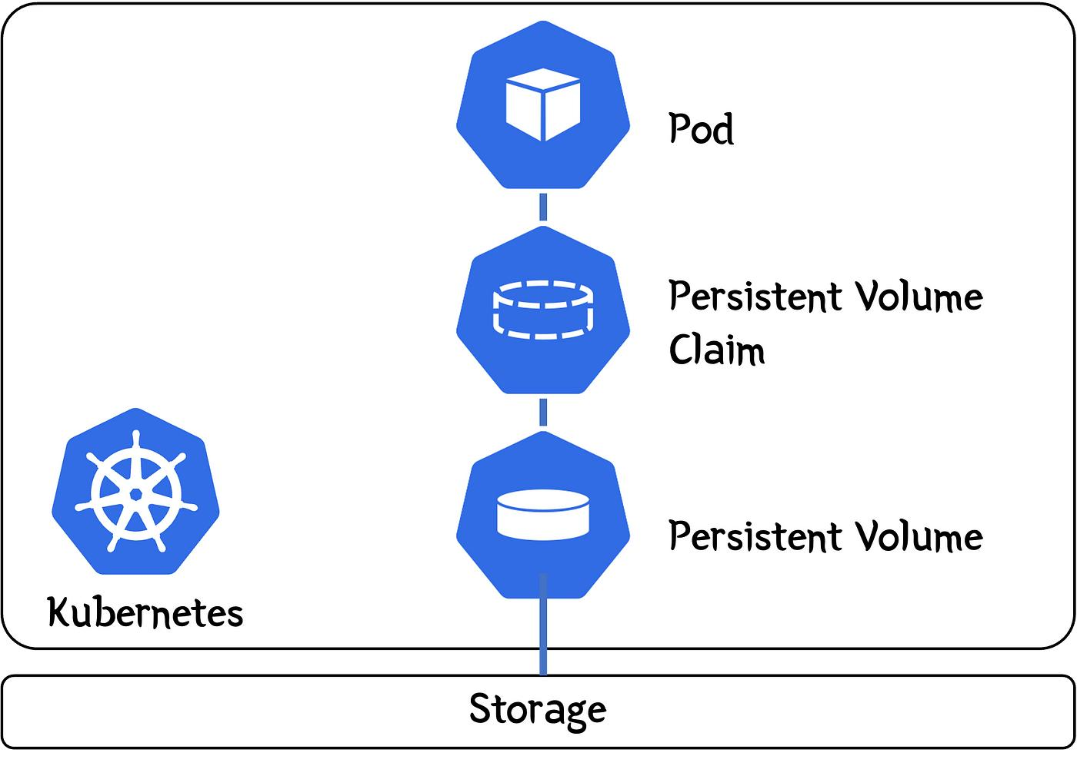

Overview
- This concept introduces durable data storage into the fundamentally ephemeral world of Kubernetes.
- It exists because containers and Pods are transient; if they die, internal data is permanently lost.
- Kubernetes uses the PV and PVC subsystems to abstract physical storage infrastructure away from the application.
- They are used extensively for stateful workloads like databases, message queues, and user file repositories.
- This system creates a distinct separation of duties between infrastructure administrators and software developers.
- It ensures data survives cluster updates, Pod crashes, and node failures.

Diagram Explanation
- The diagram depicts a linear, hierarchical supply chain for data storage.
- At the very bottom, raw Physical Storage (like AWS EBS, NFS, or local disks) exists outside or underneath the immediate cluster constraints.
- Above that, a Persistent Volume (PV) object is created by administrators to represent a specific, carved-out piece of that physical storage.
- Next, a Persistent Volume Claim (PVC) acts as a voucher. A developer creates a PVC requesting a specific size and access mode (e.g., 5GB, ReadWriteOnce).
- The Kubernetes control plane intelligently binds the PVC to an appropriate available PV.
- Finally, at the top, the application Pod mounts the PVC as a volume.
- This ensures the Pod can read and write data seamlessly. If the Pod is destroyed, the PVC and PV remain intact, safeguarding the underlying data.

Key Components
- Physical Storage:
- The actual hardware or cloud service holding the data.
- Could be an AWS EBS Volume, Google Persistent Disk, Azure Disk, or a local NFS server.
- Operates independently of the Kubernetes container lifecycle.
- Persistent Volume (PV):
- A cluster-level resource representing a piece of provisioned storage.
- Managed by the cluster administrator.
- Defines capacity, access modes (e.g., single node read/write vs multi-node read-only), and reclamation policies.
- Persistent Volume Claim (PVC):
- A namespace-level request for storage made by a developer.
- Acts as a formal ticket requesting a specific amount of storage.
- Abstracts away the underlying storage technology from the developer's application code.
- Pod Storage Mount:
- The configuration within the Pod mapping the PVC to a specific directory path (e.g., /var/lib/mysql).
- Allows the application to treat the persistent network storage exactly like a local folder.

Working Process
- The Cloud Administrator provisions a 100GB NFS share and creates a PersistentVolume (PV) object in Kubernetes representing it.
- A Developer needs 10GB of storage for a database and creates a PersistentVolumeClaim (PVC) requesting 10GB.
- The Kubernetes Storage Controller detects the PVC, finds a matching PV, and 'binds' them together.
- The Developer creates a Database Pod that references the PVC.
- The Kubelet mounts the physical NFS share directly into the Pod's filesystem.
- The Database writes data. Later, the Database Pod crashes and is rescheduled on a different Node.
- The new Pod re-attaches to the exact same PVC/PV, recovering all previous data instantly.

Advantages
- Provides total data durability regardless of application lifecycle events.
- Developers don't need to know the specific storage technology (NFS, iSCSI, EBS) to request space.
- Storage can be dynamically provisioned on-the-fly using StorageClasses.
- Protects critical stateful applications like MySQL, PostgreSQL, and MongoDB.
- Reclaim policies allow administrators to dictate whether data is retained or securely wiped when the PVC is deleted.

Common kubectl Commands
- kubectl get pv - Lists all physical storage volumes provisioned globally across the cluster.
- kubectl get pvc - Lists all storage claims in the current namespace and their binding status.
- kubectl describe pvc <name> - Shows detailed events, capacity, and the specific PV the claim is bound to.

Summary
- PVs represent actual physical storage capacity provisioned by administrators.
- PVCs are requests for storage capacity made by developers.
- Kubernetes acts as a broker, binding developer claims (PVCs) to available resources (PVs).
- Pods mounts PVCs, allowing applications to persist data beyond container restarts.
- This architecture ensures a clean separation of infrastructure management and application development.
- It is the absolute requirement for running any stateful application in a Kubernetes cluster.

